


Wellbeing advice for working from home for Staff
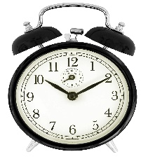
Set your alarm
This Photo by Unknown Author is licensed under CC BY-SA
Sticking to a familiar routine really helps - it’s still a workday. Keep your alarm set to its usual time and get showered and dressed by the time you’d usually be leaving the house to commute to work and only start work once you’re ready for the day. If you can, use the time you would normally spend travelling to work to get outside and go for a walk, this helps to avoid the ‘straight from bed to desk trap’.

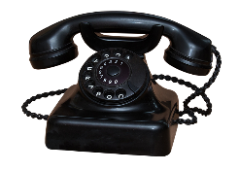
Maintaining regular contact with your manager and colleagues
Setting up a regular skype call with your team can be helpful to feel connected, it provides an opportunity to share concerns, workloads and offer help and support to each other. Keep communication positive and try to use skype to video call. It can create a better connection and it will help reduce any feelings of isolation incurred by not working face to face. A WhatsApp group can also help, it can feel like interacting on more of a personal level and can be faster when an emergency response is appropriate.


Taking regular breaks
This Photo by Unknown Author is licensed under CC BY-SA
Don’t be ‘on’ all the time. Be aware that if you were in the office you would make a coffee, pop to the shop, catch up with a colleague. Try not to fixate on or worry about being chained to the laptop. Put the kettle on, load the washing machine, go for a lunchtime stroll but ensure that you identify non-working time in your calendar and keep an eye on your hours.


Marking the end of the day
Like your new morning ‘commute’, develop a ritual to end the working day. If you can, put your computer away, tidy your working area, go for a half-hour stroll or try an indoor workout. Find a way to naturally signal the end of your workday and establish some boundaries.
Prioritising downtime and sleep
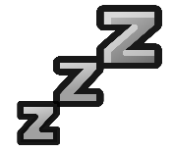
We all know that stress and uncertainty can change our sleeping patterns, so try to be mindful of this. Just like waking, keep to your regular bedtime and add in some relaxation before you try to sleep. Keep phones and scrolling far away from the bedroom if possible.
This Photo by Unknown Author is licensed under CC BY-SA

Doing something fun

With no clear differentiation between ‘work life’ and ‘home life’ it can be hard to not feel work pressure at all times, when you are working from home and no longer spending time in the car or walking to the office. Try reallocating that time to something you enjoy. As above this could be going for a walk or getting out of the house but maybe it could be rediscovering a hobby you didn’t have the time for or doing something that will make you feel good or alleviate some stress.

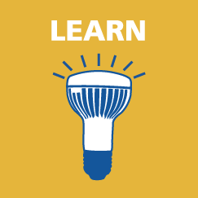
Educate yourself but don’t overwhelm yourself
The situation with Coronavirus is changing every day, but too much information can be overwhelming. Perhaps allow yourself to check the news or look at government resources during your lunch break or after work. Remember, if it gets too much, switch off.


Being aware of the things that can cause you poor wellbeing and the activities and resources that can help to address this
Eat right, eat at regular hours of the day. Eating right can minimise your risks of getting ill and fuel your body. For more tips on eating well, please see https://www.nhs.uk/live-well/eat-well/ . Keep on top of usual household chores so your working environment is clean and uncluttered. Look after yourself.

Sources
These tips have been taken from the following sources, which you may find useful to look at in more detail:
- https://happiful.com/working-from-home-7-steps-for-a-better-work-day/
- https://www.bbc.co.uk/news/business-51868894
- https://www.bbc.co.uk/news/business-51804354
- https://www.theguardian.com/lifeandstyle/2019/mar/25/extreme-loneliness-or-the-perfect-balance-how-to-work-from-home-and-stay-healthy
- https://www.sciencemag.org/careers/2020/03/working-home-because-covid-19-here-are-10-ways-spend-your-time
- https://www.standard.co.uk/lifestyle/wellness/self-isolation-tips-a4388191.html

